**Project Case study – 1**

Use the Adventures Data Set for Below Usecases



**Use case 1**: Display top 5 Product and its respective sales Amount in chart and table

**Slicer**: Top 5, Top 10, Top 20, Top 30

1. Have 2 charts. One responding to slicer and another which remains the same showing only top 25 pdts

**Usecase 2:**

1. Please work on the hyperlink.

* Full Url need not be shown.
* On clicking the hyperlink I need a new report opening up with a table and a chart showing details of that particular data.
* You can use any data source or it can be a simple data set created via Enter Data.

You can use any chart also try to explore all the features in table and chart.

**Usecase 3:**

Display top 3 countries Sales and their top 5 products.Output should be as below.

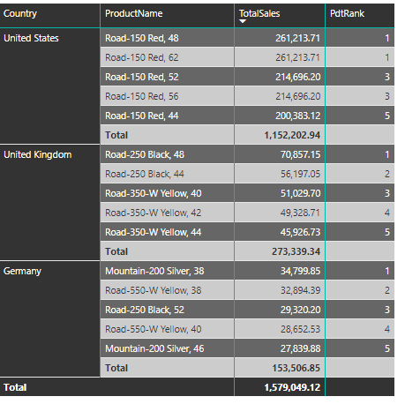

**Usecase 4**

Slicer: Last 7 days, Last 30 days, Last 90 Days, Last 12 months, Last 24 months, Other

1.Display Sales, Product Name, Date, etc (other required fields).

2. Other : dates before 24 months.

Give the report a title ,table header.

Choose appropriate fonts and make visuals look beautiful.

**Usecase 5:**

I need three tables in the report as follows:

1. Average of Sales
2. Percentage of Sales(Total Percentage should be 100)
3. Percentage of sales grouped by country (Total Percentage for each country should be 100)